Best Practice Overview 1 Page for National Groups

Date: 8-19-20

Author: April Gucciardi

Objective: Provide examples of best practices for introducing plans to national groups with Imagine Health and ELAP. Also show clients/brokers that we have experience handling these types of plans.

Audience: Brokers/Clients

Notes: Use plan differential piece we created for Chris as a starting point

Branding: Imagine/ELAP

_______________________________________________________________________________

When it comes to saving money on healthcare, Imagine Health and ELAP Services have more than 12 years of experience. With Imagine Health, your employees get direct access to quality healthcare providers and a cost containment solution from ELAP Services for care outside of Imagine.

We work with self-funded employers of all sizes to provide measurable savings and drive real results. Plan details can vary based on your group size, but our team will work together with you and your Third-Party Administrator (TPA) to build a plan design that is right for you.

The below implementation options are examples of just two different ways we can help structure your health plan.

Implementation Plan #1

This plan option gives all employees the ability to seek care from the provider of their choice. However, they will maximize their benefits and reduce out-of-pocket costs if they choose a provider who participates in Imagine Health.

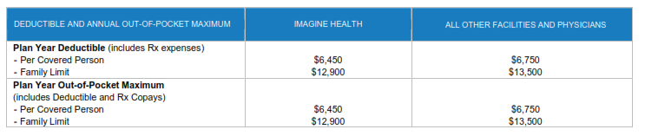





Implementation Plan #2: (Goes with Graphics 2&3)

This plan option requires separate benefits materials for your different employee groups. Employees within Imagine markets will maximize their benefits if they choose a provider who participates in Imagine Health.

*Sample Graphic 2:* Imagine Health Market Employees (Recreate and Remove our company names – First column Imagine Health, Second Column PHCS Physicians, 3rd as-is)



*Sample Graphic 3:* Non-Imagine Health Market Employees (Recreate and Remove our company names – First column Imagine Health, Second Column PHCS Physicians, 3rd as-is)



*Sidebar chart:*

Here’s a quick overview of two sample implementation plans:

|  |  |  |
| --- | --- | --- |
|  | Implementation Plan #1 | Implementation Plan #2 |
| Plan Design | One design for all employees nationwide | Separate designs for Imagine and Non-Imagine markets |
| Open Enrollment Meetings | One OE Meeting for all Employees | Meetings by market OR two OE meetings: one for IH markets and one for ELAP markets |
| ID Cards | All have Imagine logo | Imagine logo only for those in Imagine markets |
| Finding a Provider | Visit providers.imaginehealth.com or call TPA for assistance | Depends on Market – all can call TPA for assistance |

Footer:

PHONE: 610-321-1030 | EMAIL: info@elapservices.com